**Software Engineering- Semester Project**

**One Stop Degree Issuance System**

**Submitted By: Humna Shafique – 21I-2464**

**Muskan Imran-- 21I-0774**

**Aqsa Rashid--21I-2452**

**Ayesha Sajid—20I-0862**

**Submitted to: Ma’am Javeria Imtiaz**



**Introduction:**

Our project aims to streamline the student services experience by centralizing all support functions into one accessible platform. With a focus on degree issuance, we're creating an online system that allows students to seamlessly request and track the progress of their degree issuance process. Administrators will have tools to efficiently manage and track requests, ensuring transparency and timely processing.

**Rationale:**

The current manual processing system leads to inefficiencies, delays, and communication gaps, impacting both students and administrative personnel. By digitizing and centralizing the degree issuance process, we aim to enhance efficiency, communication, and transparency, ultimately improving the student experience and reducing administrative burden.

**Architecture:**

Our project adopts a modular architecture, with separate modules for student and administrative functionalities. The system comprises a frontend interface for students to interact with, including features for submitting requests, raising concerns, and tracking progress. On the backend, there are administrative modules for managing requests, tracking processing times, and ensuring timely responses.

**Justification:**

We chose a modular architecture for its scalability and flexibility. This architecture allows us to easily add or modify features in the future without disrupting the entire system. Additionally, by separating student and administrative functionalities into distinct modules, we ensure clarity in development and maintenance, as well as better control over access rights and permissions. This architecture aligns with our goal of creating an efficient, user-friendly, and adaptable system for simplifying student services.

**Product Backlog**

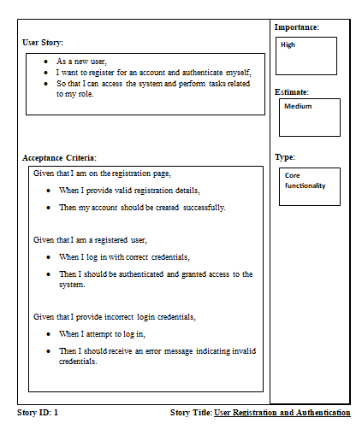

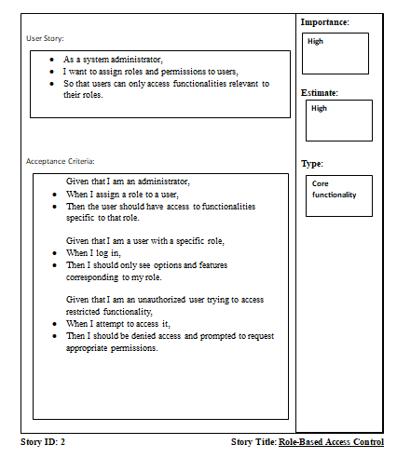

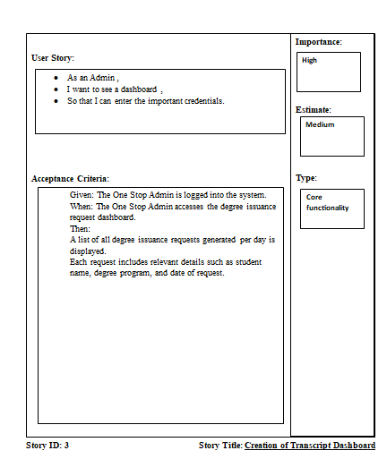

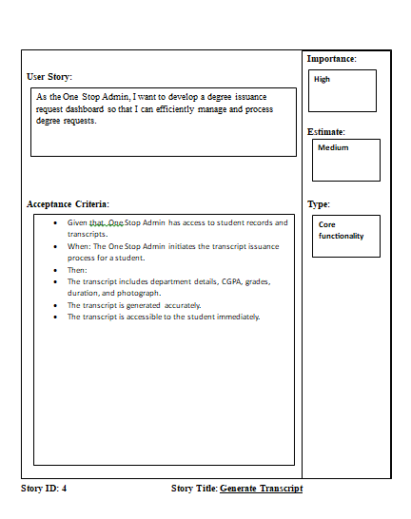

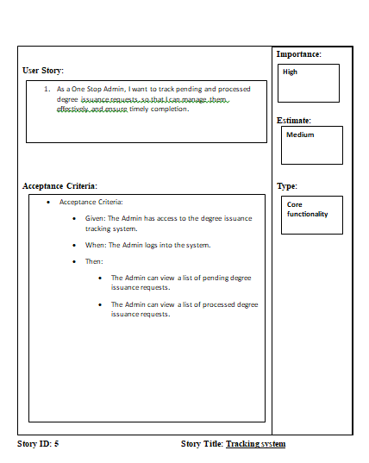

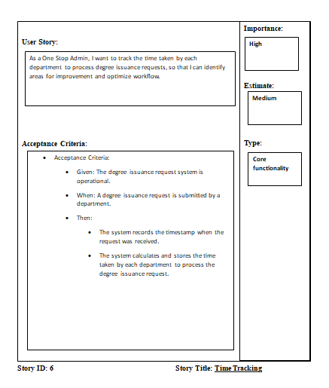

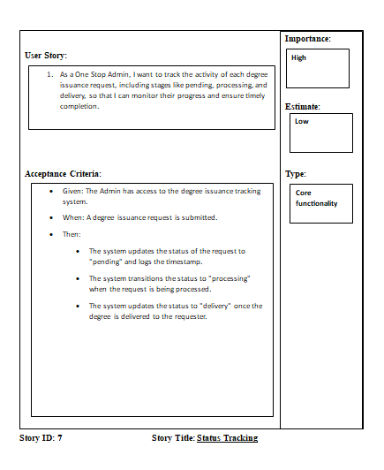

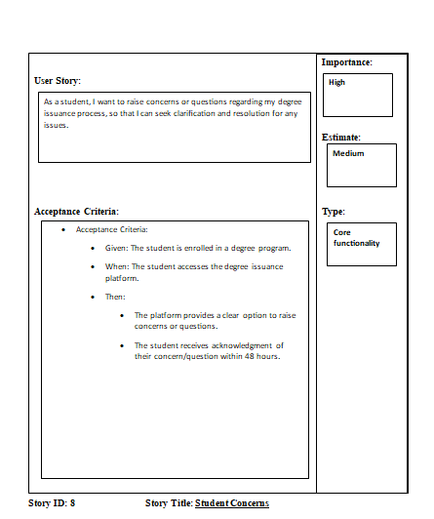

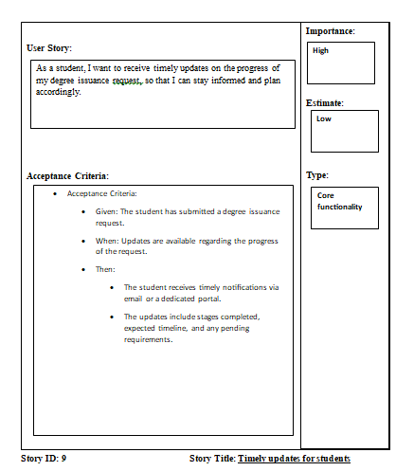

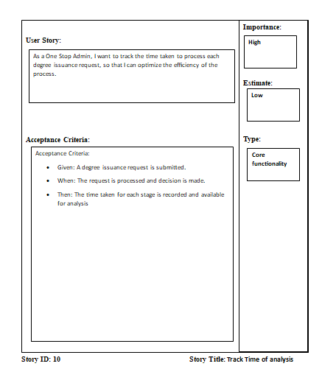

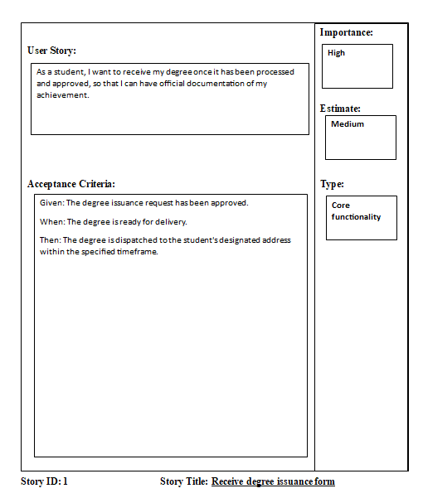

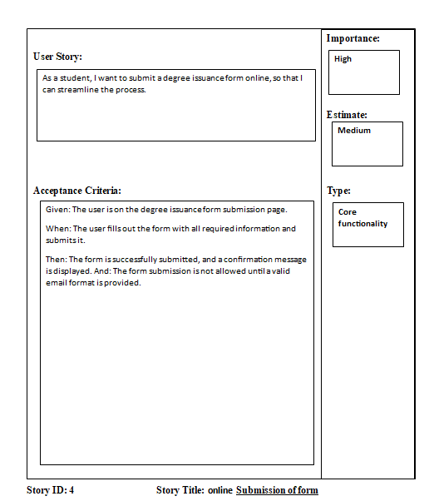

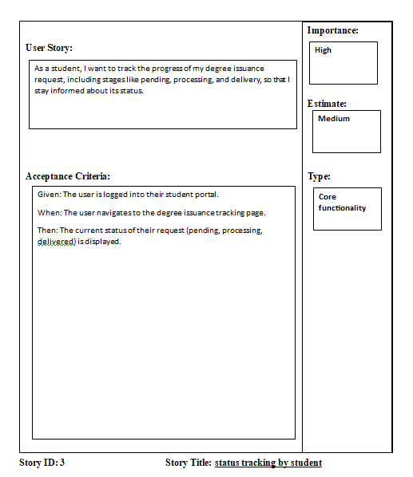

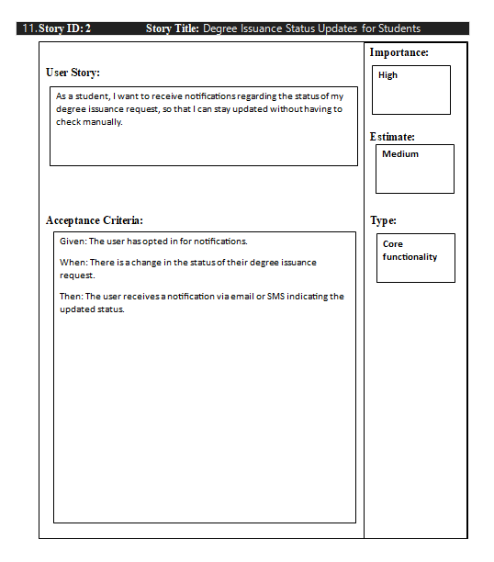

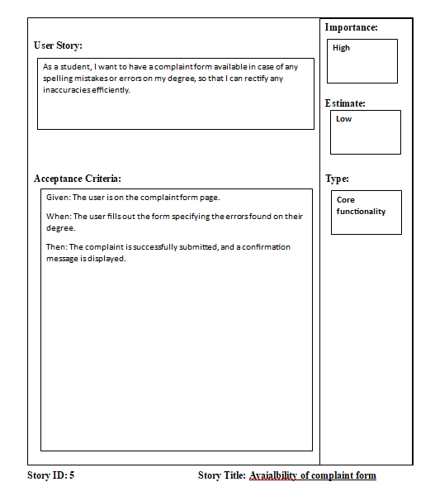

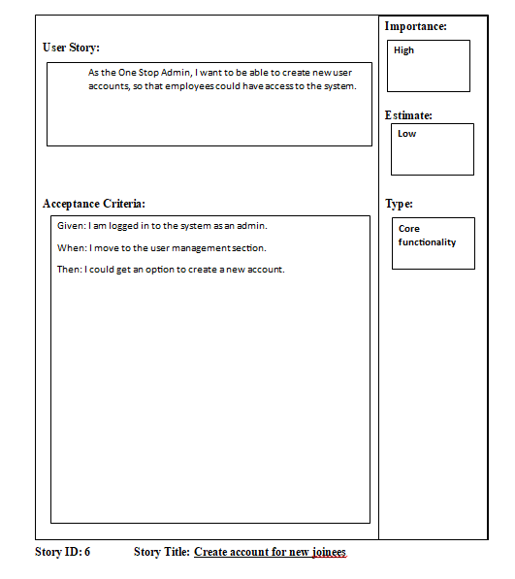

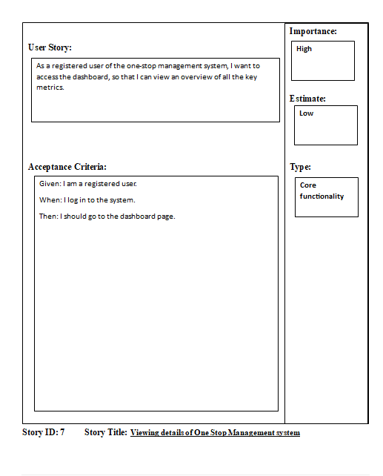

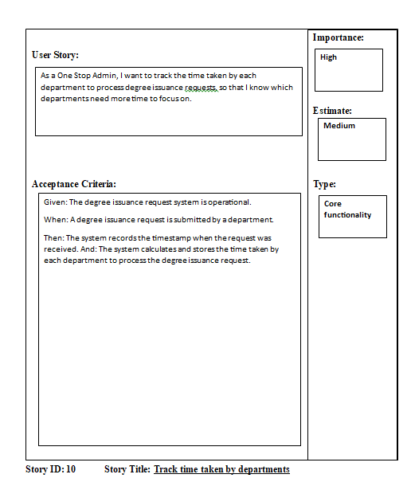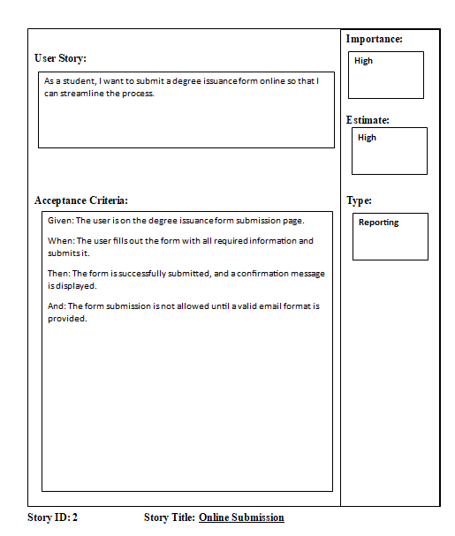

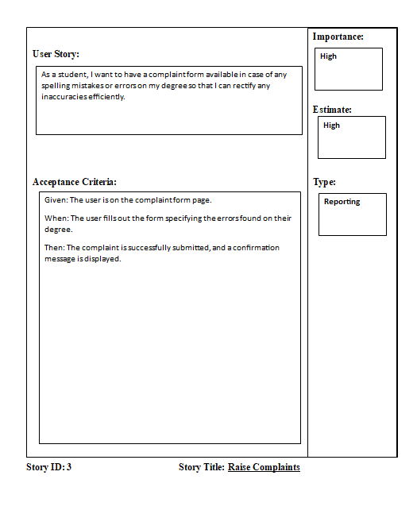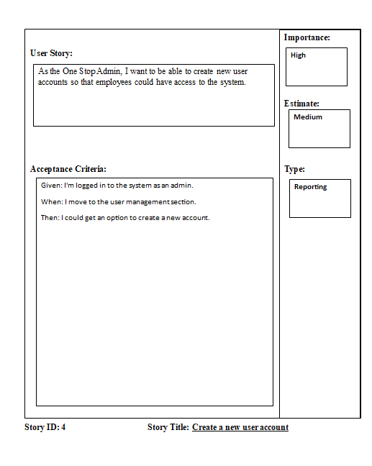

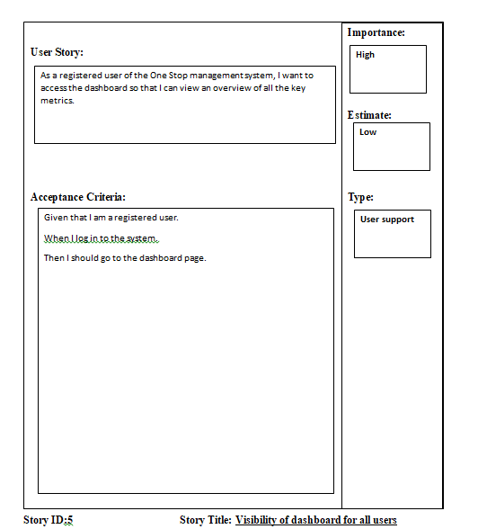

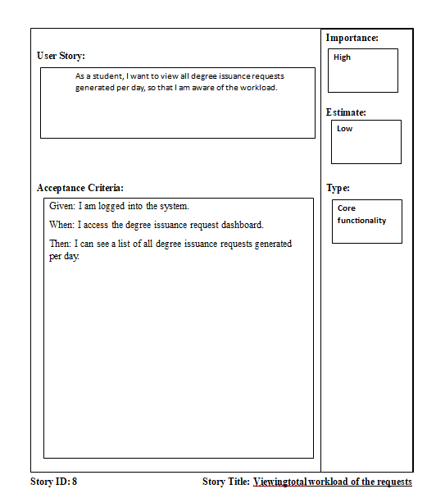

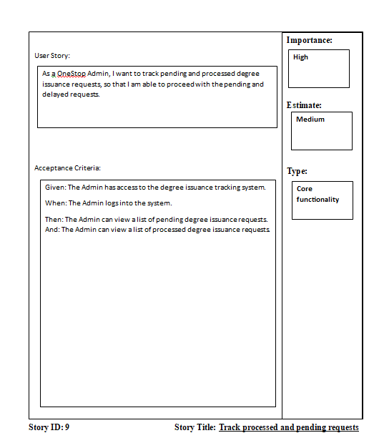

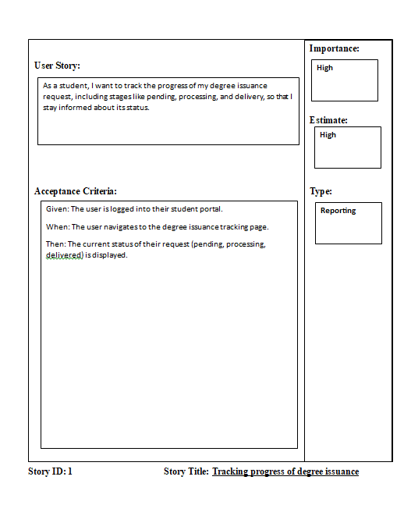

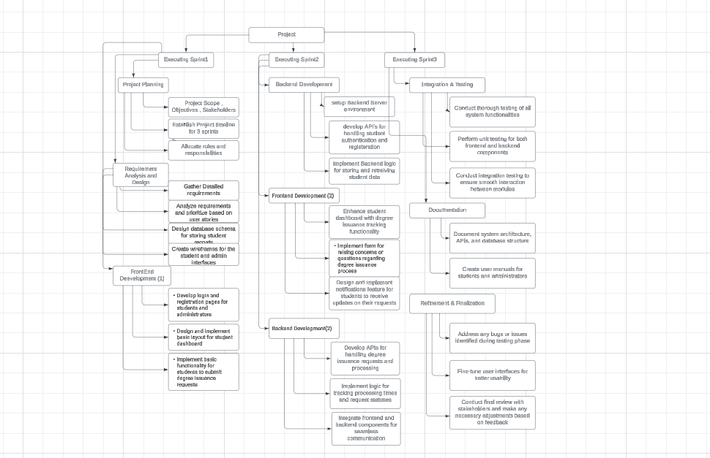

**Project Planner**

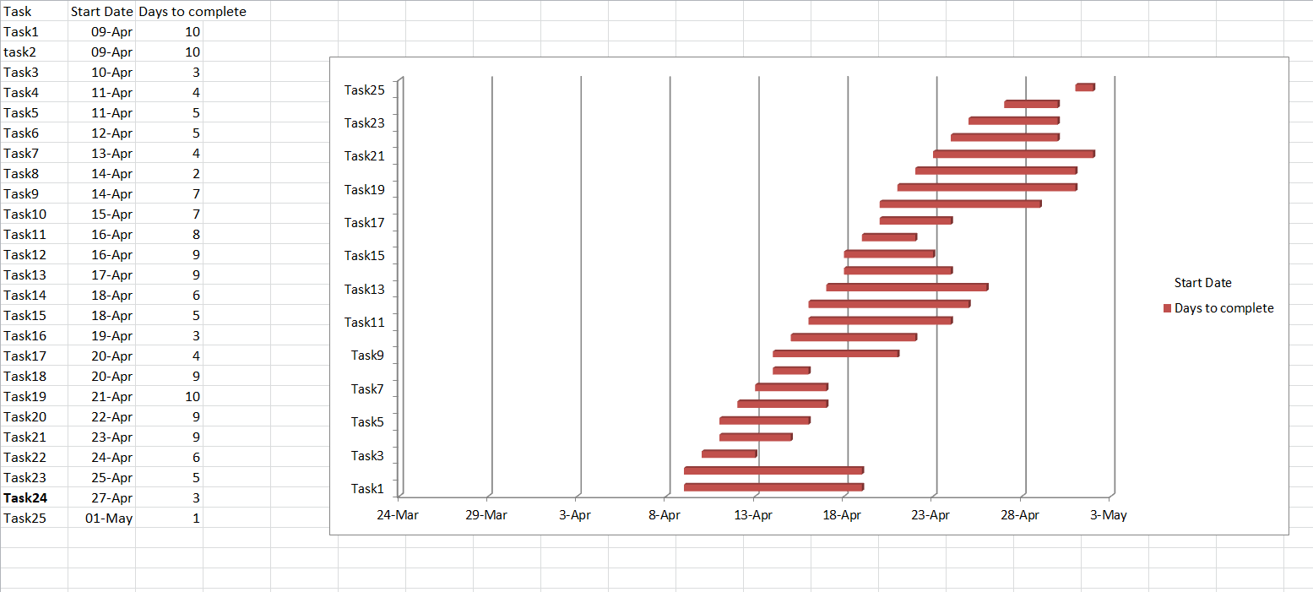

**Gantt chart**

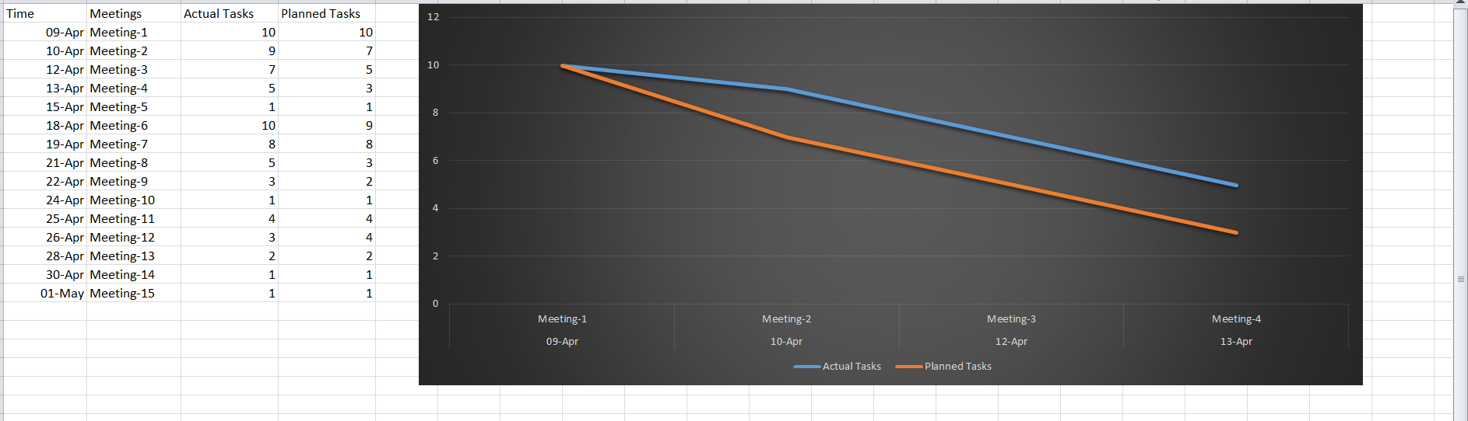

**Full Burndown Chart**

**Screenshots of GUI**

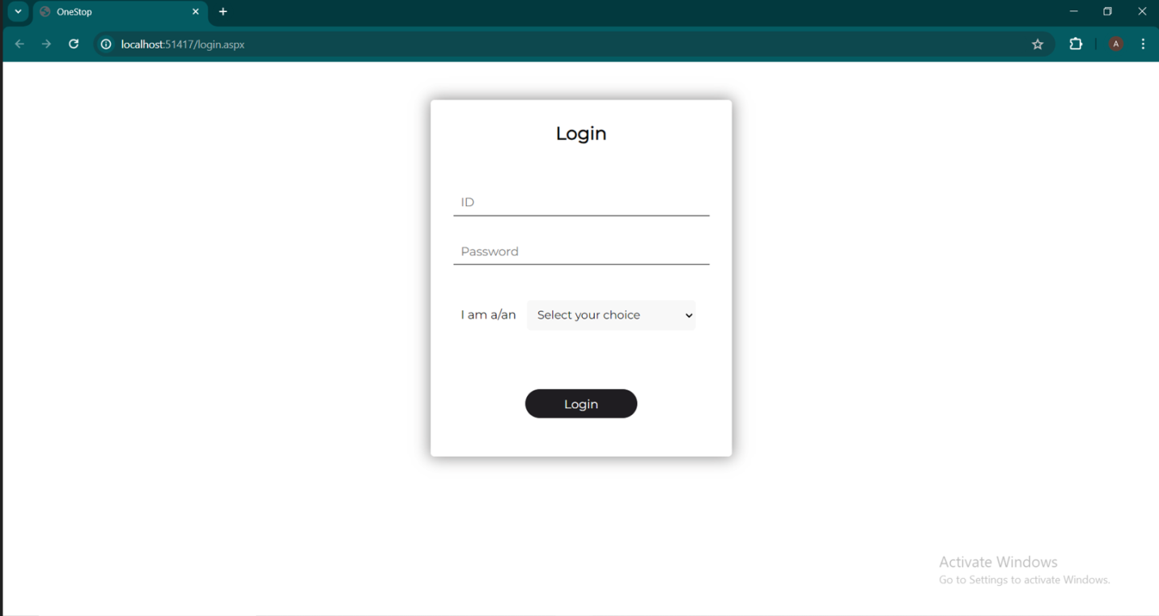

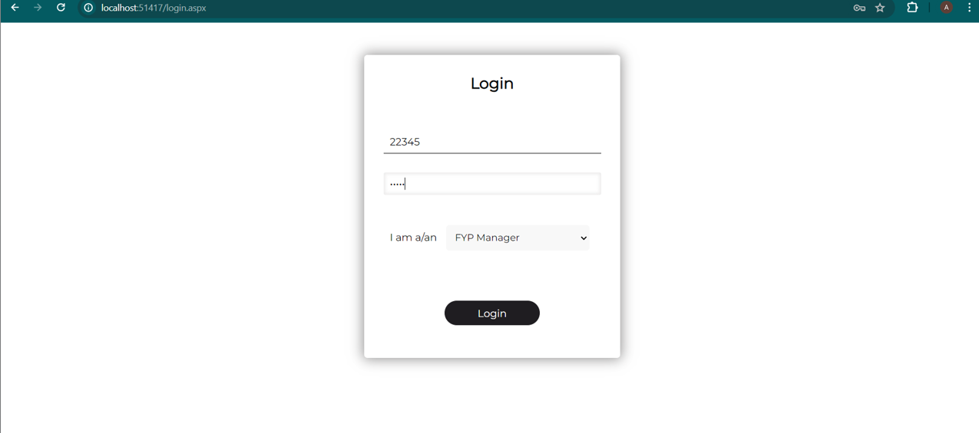

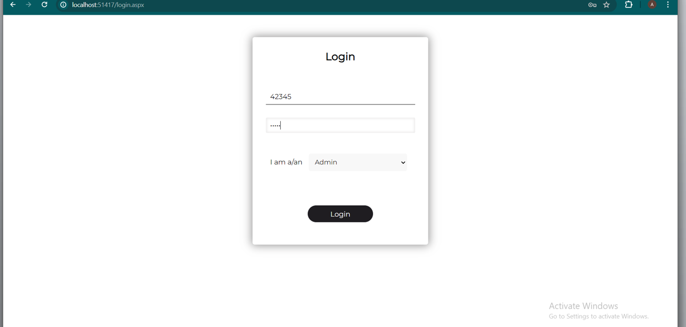

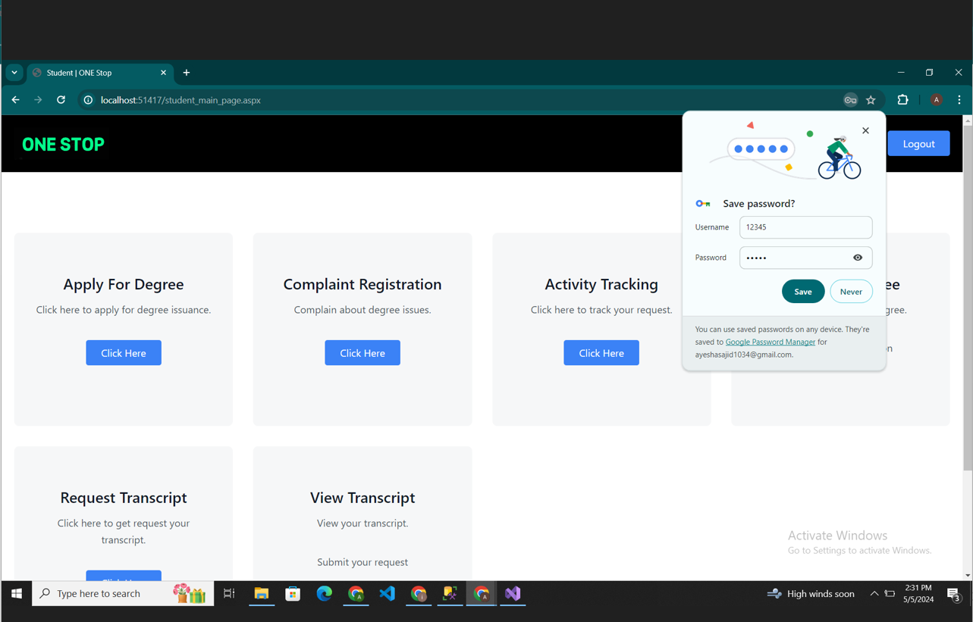

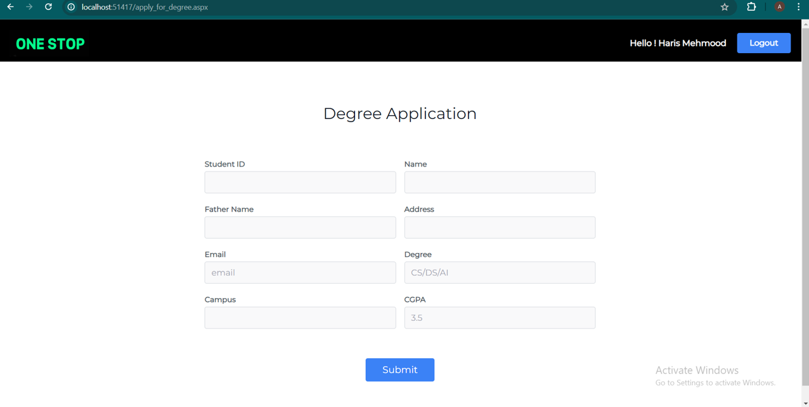

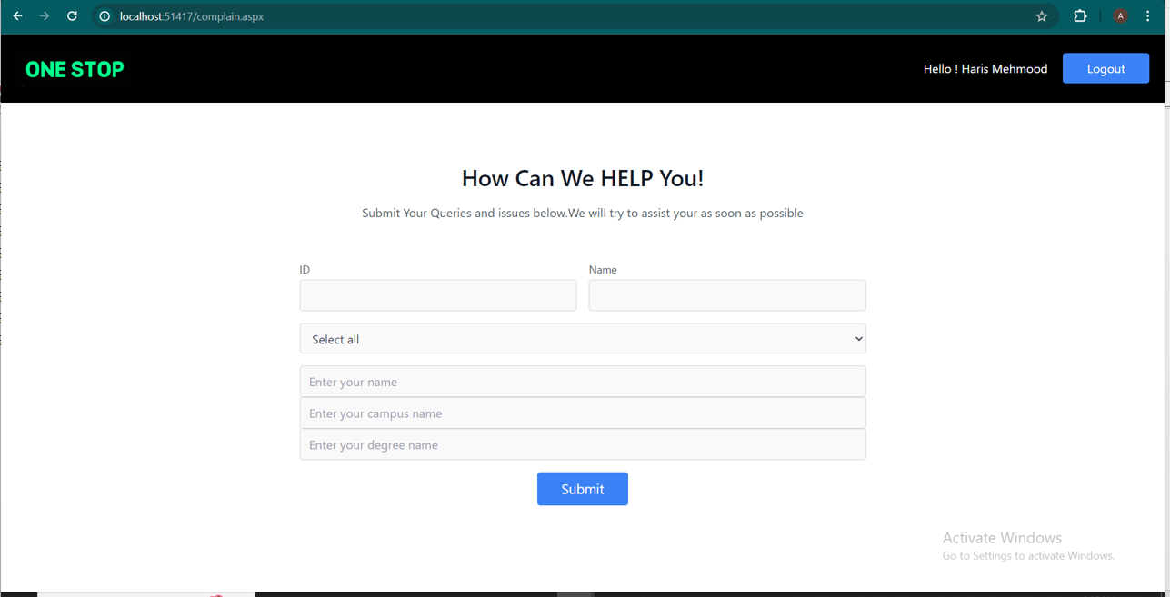

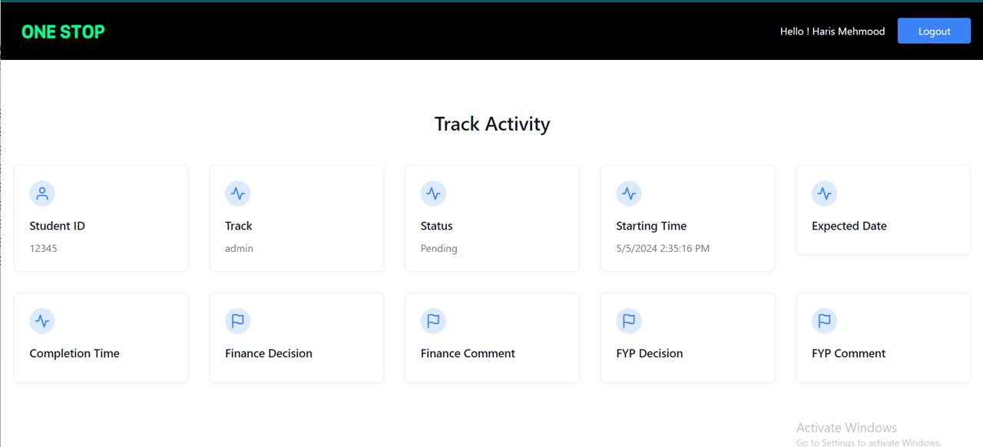

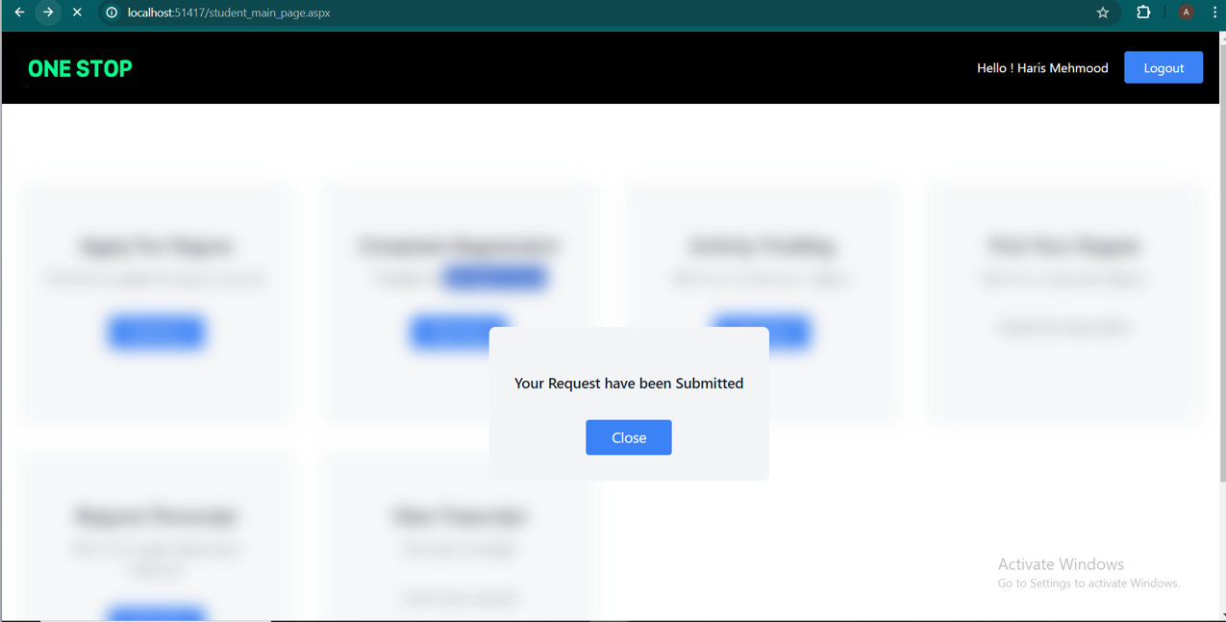

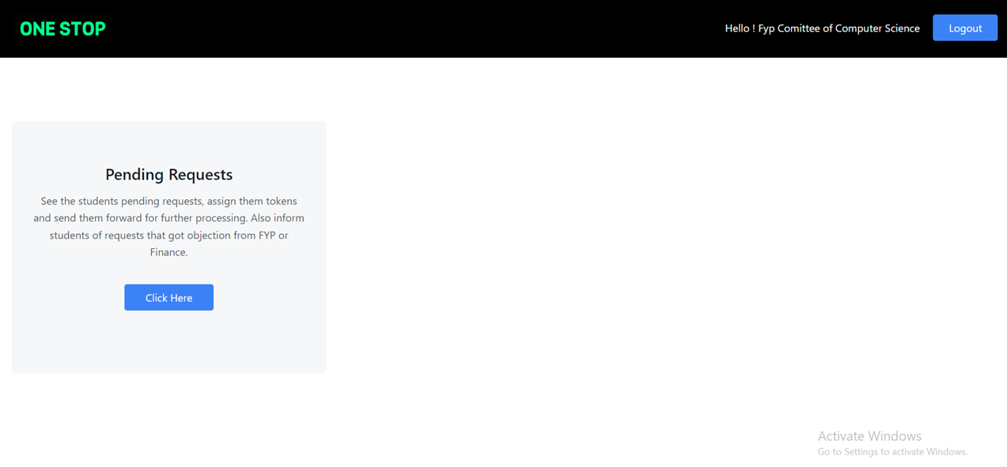

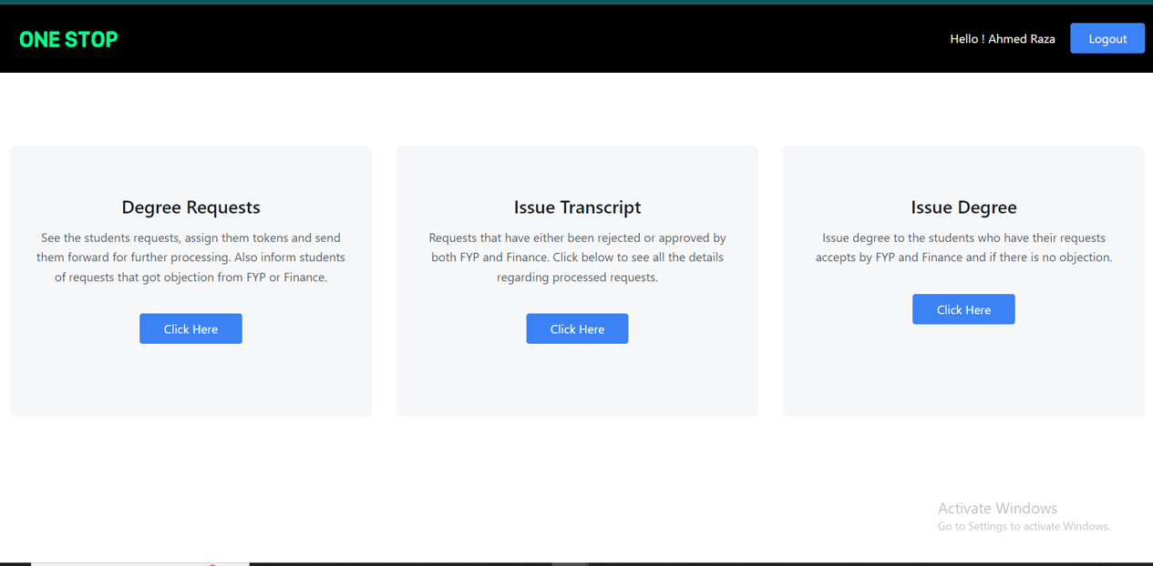

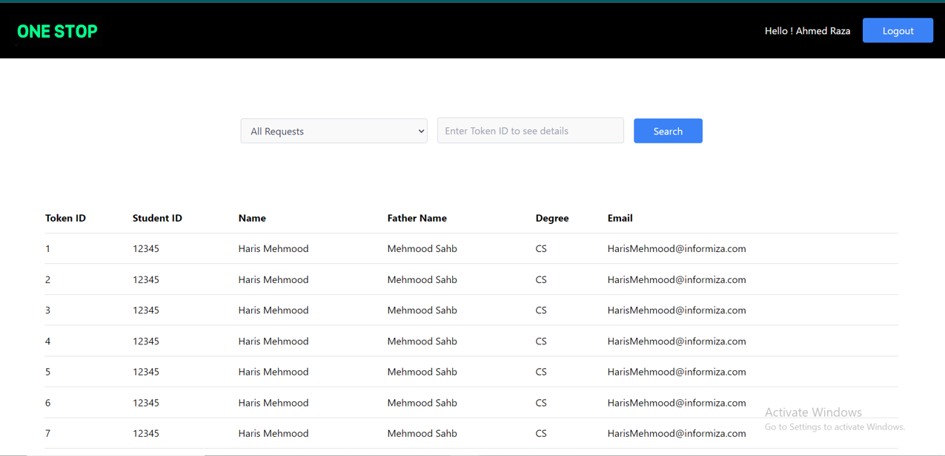

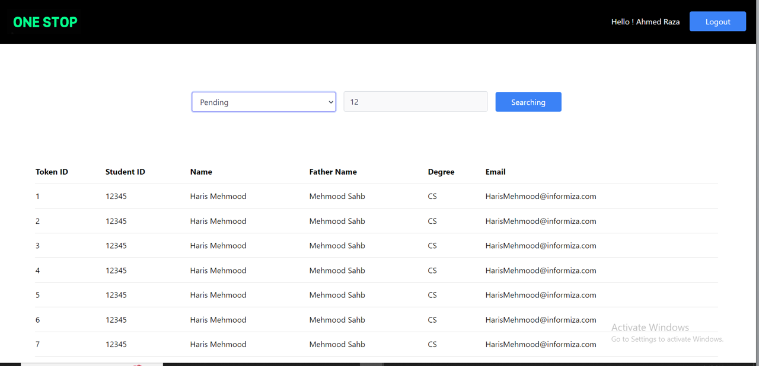

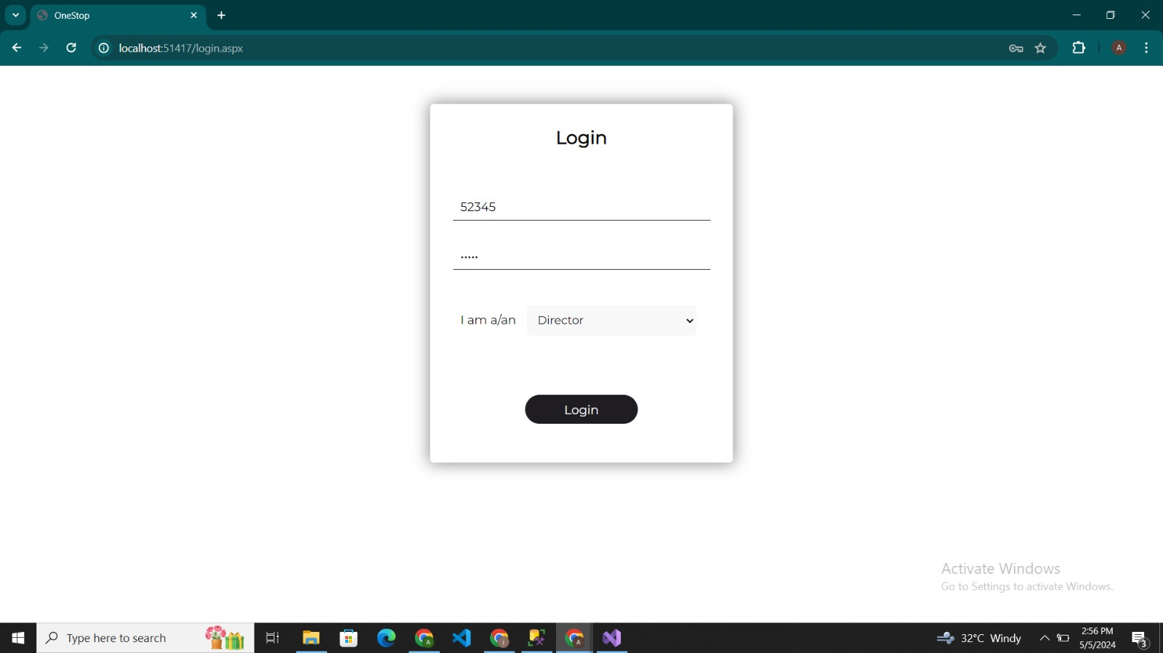

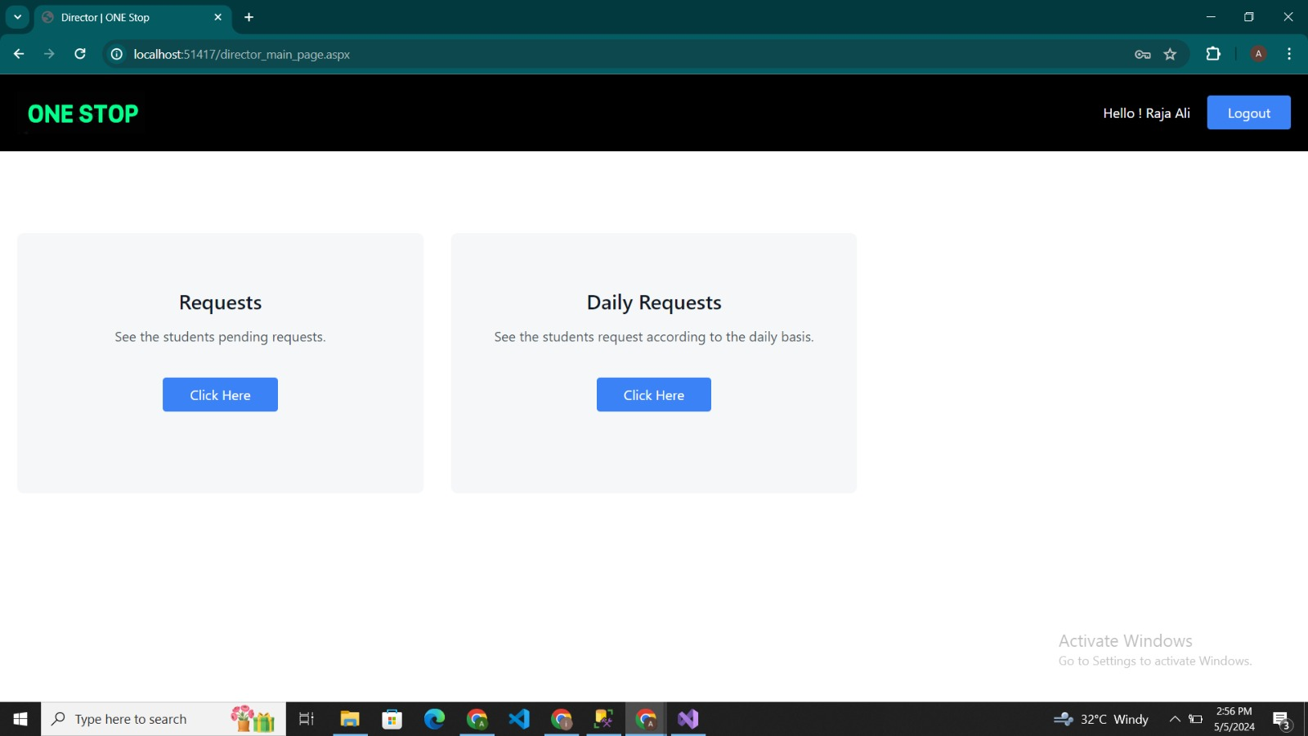

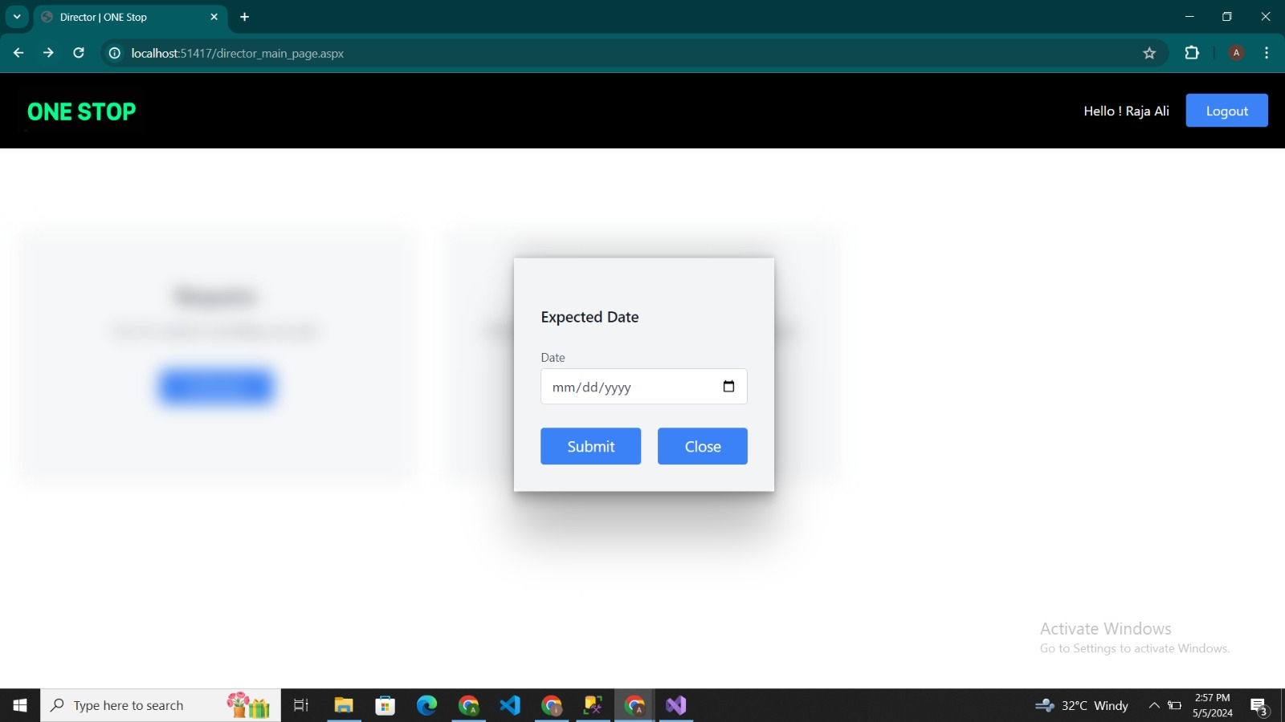

**Equivalent Class Partitions and Boundary Analysis**

**Equivalent Class Partitions**:

**Login Page**

|  |  |  |
| --- | --- | --- |
| **Input or Output Event** | **Valid Equivalence Classes** | **Invalid Equivalence Classes** |
| ID Field – The Admin , Student , Director has to login to have access to admin dashboard | Integers only with length <= 255. | Integers only with length >= 255. |
| Password Field – The Admin has to login to have access to admin dashboard | Alphabets only with length <= 255 and Special character only with length=1 | Alphabets with length >= 255.and special characters with length>1 |

**Boundary Value Analysis**:

|  |  |
| --- | --- |
| **Input** | **Boundary Value** |
| ID | ID of Integer length <= 10 is boundary value and is accepted. |
| Password | Password of Integer length <= 6 and special character<=6is boundary value and is accepted. |

**Equivalent Class Partitions**:

**Degree Application Page**

|  |  |  |
| --- | --- | --- |
| **Input or Output Event** | **Valid Equivalence Classes** | **Invalid Equivalence Classes** |
| Student ID Field – The Student has to enter student ID | Integers only with length <= 10. | Integers only with length >= 10. |
| Name Field – The Student has to enter his/her name | Alphabets only with length <= 255 | Alphabets with length > 255. |
| Fathers Name Field – The Student has to enter his registered father name | Alphabets only with length <= 255 | Alphabets with length > 255. |
| Address Field – The Student has to enter his/her address | Alphabets only with length <= 255 and integer within length <=255 | Alphabets with length > 255 and integer with length>255 |
| email Field – The Student has to enter his registered email | Alphabets only with length <= 255 , integer within length <=255 and special characters<=255 and “@” with length=1 | Alphabets with length > 255.  Integer with length>255 , and special character with length>255 , and”@” with length!=1 |
| Address Field – The Student has to enter his/her address | Alphabets only with length <= 255 and integer within length <=255 | Alphabets with length > 255 and integer with length>255 |
| Campus Field – The Student has to enter the campus name where he/she is enrolled | Alphabets only with length <= 255 | Alphabets with length > 255. |
| Department Field – The Student has to enter his/her Respective department | Alphabets only with length <= 255. | Alphabets with length > 255 |
| CGPA Field – The Student has to enter his/her CGPA | integer with length =2 and range 0.0-4.0 | integer with length>2 and range >4.0 |

**Boundary Value Analysis**:

|  |  |
| --- | --- |
| **Input** | **Boundary Value** |
| ID | ID of Integer length <= 10 is boundary value and is accepted. |
| Name | Name of alphabet length <= 255 is boundary value and is accepted |
| Father’s name | Name of alphabet length <= 255 is boundary value and is accepted |
| Campus | Campus of alphabet length <= 255 is boundary value and is accepted |
| Department | Department of alphabet length <= 255 is boundary value and is accepted |
| Email | Email of Alphabet length <= 255, integer of length<=255 , “@”with length=1 and special character<=255 is boundary value and is accepted. |
| CGPA | CGPA of integer length =2 and range =4.0 is boundary value and is accepted. |
| Address | Address of alphabet length <= 255 and integer length<=255 is boundary value and is accepted |

**Equivalent Class Partitions**:

**How can we Help You Page**

|  |  |  |
| --- | --- | --- |
| **Input or Output Event** | **Valid Equivalence Classes** | **Invalid Equivalence Classes** |
| ID Field – The Student has to enter ID | Integers only with length <= 10. | Integers only with length >= 10. |
| Name Field – The Student has to enter his/her name | Alphabets only with length <= 255 | Alphabets with length > 255. |
| Campus Name Field – The Student has to enter his Campus name where he/she is enrolled | Alphabets only with length <= 255 | Alphabets with length > 255. |
| Degree name Field – The Student has to enter his/her Respective degree | Alphabets only with length <= 255 | Alphabets with length > 255 |

**Boundary Value Analysis**:

|  |  |
| --- | --- |
| **Input** | **Boundary Value** |
| ID | ID of Integer length <= 10 is boundary value and is accepted. |
| Name | Name of alphabet length <= 255 is boundary value and is accepted |
| Campus name | Campus Name of alphabet length <= 255 is boundary value and is accepted |
| Degree name | Degree name of alphabet length <= 255 is boundary value and is accepted |

**Trello Snapshots**

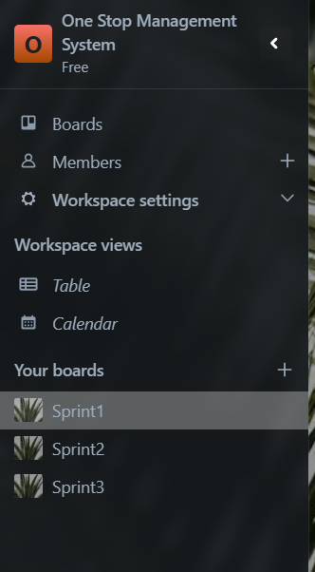

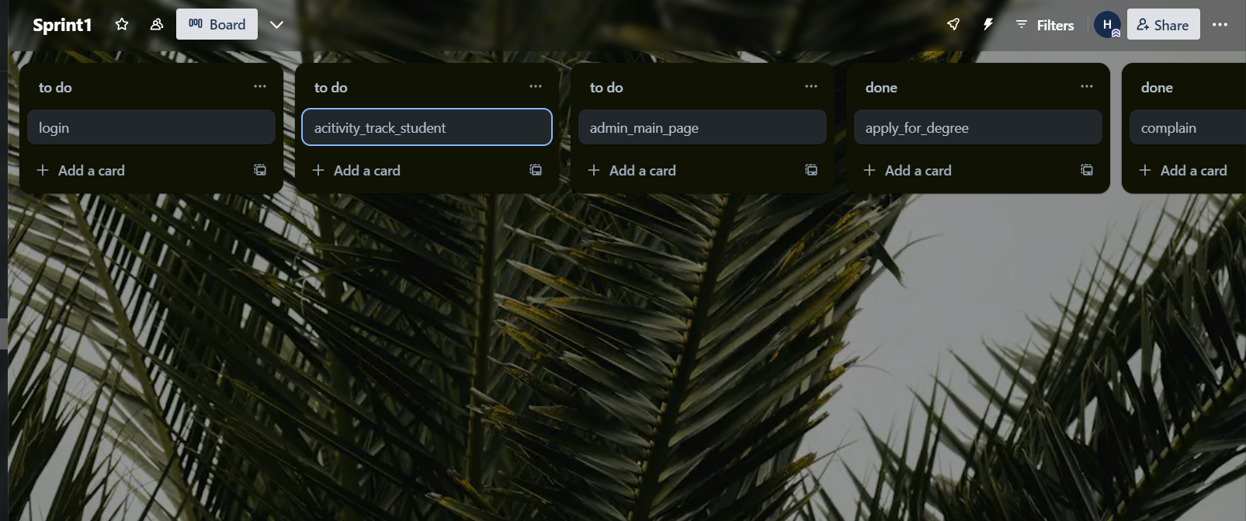

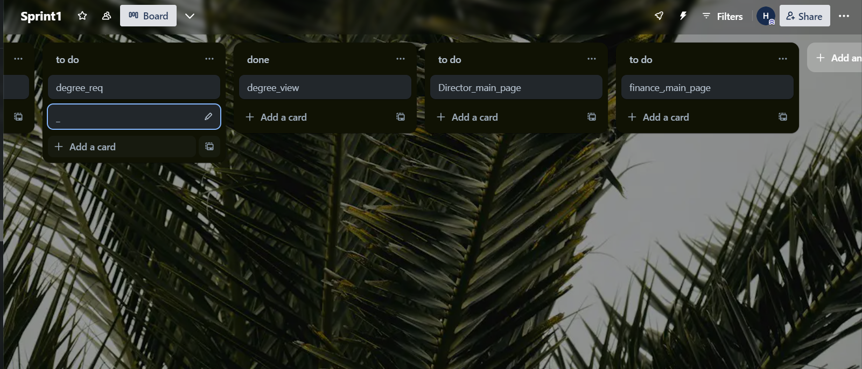

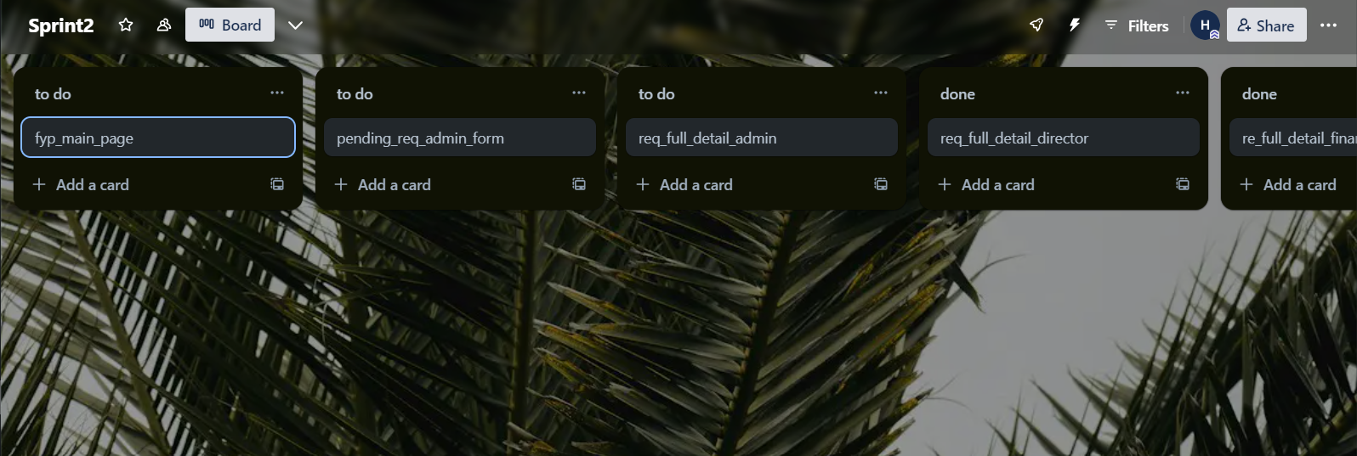

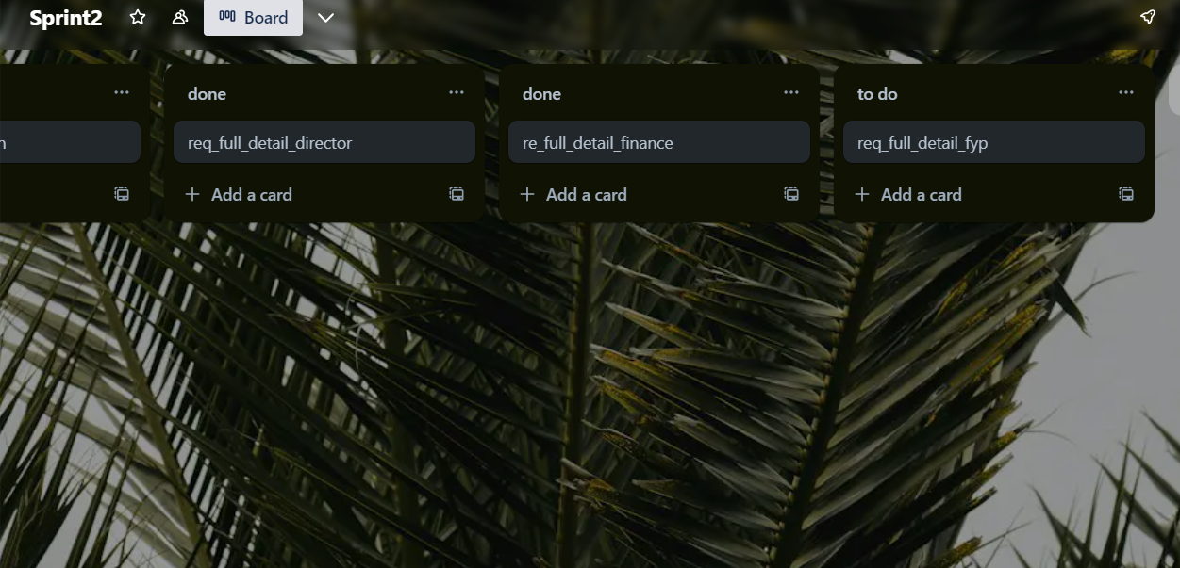

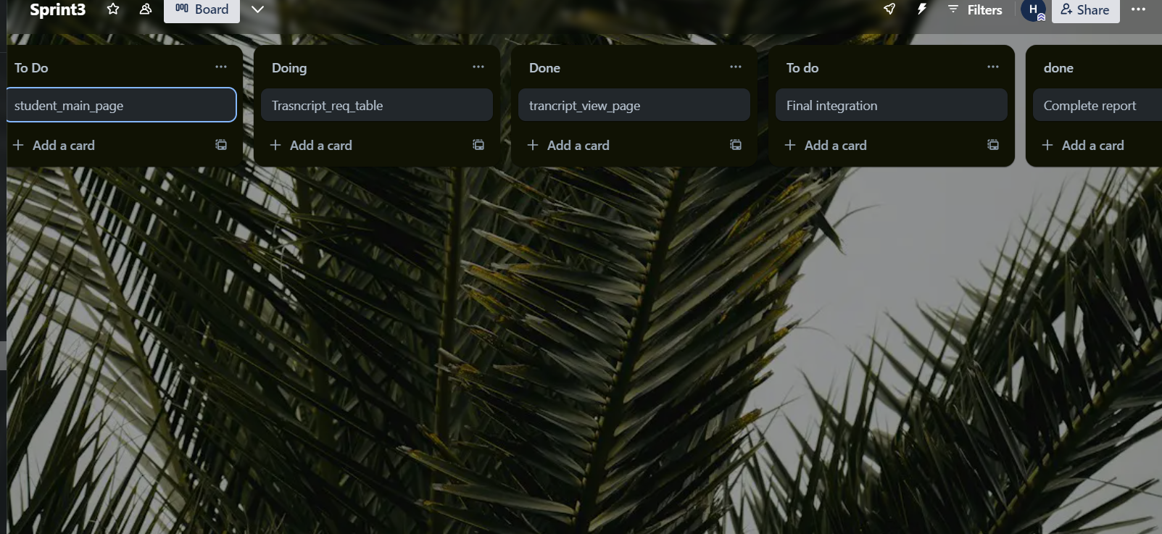

**Product Review: One Stop Degree Issuance System**

**Overview:**

The One Stop Degree Issuance System aims to simplify the process of issuing degrees to university students by providing a centralized platform for submitting requests, tracking progress, and receiving timely updates. The system consists of both student and administrative modules, offering features such as degree request submission, progress tracking, notifications, and support for raising concerns.

**Strengths:**

**Centralized Platform**: The system provides a centralized platform for students to request degree issuances and for administrators to manage and process these requests, reducing the need for manual paperwork and communication.

**Transparency and Communication:** By allowing students to track the progress of their requests and receive timely updates, the system enhances transparency and communication between students and administrators, reducing confusion and frustration.

**Efficiency:** Automation of degree issuance processes and tracking of processing times improve efficiency, reducing processing delays and ensuring timely delivery of degrees to students.

**User-Friendly Interface:** The user interface is intuitive and easy to navigate, making it accessible for both students and administrators to use the system effectively.

**Limitations:**

**Limited Functionality:** While the system covers the basic functionalities required for degree issuance, it may lack advanced features such as analytics for tracking trends in issuance requests or integration with external systems for document verification.

**Scalability:** The system's scalability may be a concern as the university grows and the volume of degree issuance requests increases. It may require additional resources and infrastructure to handle a larger student population efficiently.

**Dependency on Technology:** Reliance on technology infrastructure such as servers, databases, and internet connectivity introduces the risk of downtime or technical issues, potentially disrupting the degree issuance process.

**User Training:** Although the system is designed to be user-friendly, adequate training and support may be required for both students and administrators to fully utilize its features and functionalities.

**Improvements:**

**Enhanced Analytics:** Integrate analytics features to track and analyze trends in degree issuance requests, processing times, and student satisfaction, providing insights for process optimization and decision-making.

**Integration with External Systems:** Explore options for integrating the system with external verification systems or databases to streamline the verification process and enhance the integrity of degree issuance.

**Mobile Accessibility:** Develop a mobile-responsive interface or dedicated mobile application to allow students to access the system conveniently from their smartphones, enhancing accessibility and user experience.

**Automated Notifications:** Implement automated notifications for administrators to receive alerts for pending requests, overdue tasks, or system errors, enabling proactive management and response.

**Scalability Planning:** Conduct scalability assessments and develop a roadmap for scaling the system to accommodate future growth in student population and degree issuance volume, ensuring continued efficiency and performance.